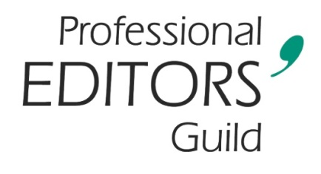
9 January 2026
To all PEG members
IMPORTANT ANNOUNCEMENT
In mid-September 2025, 15 courageous PEG members committed themselves to writing the Guild’s sixth annual Accreditation Test. We both thank and commend them for doing so. Of that group, six rose to the occasion, attaining the benchmarked standard required to elevate their status as professional editors.
This means that, with the commencement of membership year 2026–2027 on 1 March, the following PEG members who sat and were successful in taking the 2025 PEG Accreditation Test will be able to emblazon their hard-won status as Accredited Text Editors (English) on their email signatures and other marketing materials.
It gives your Executive Committee great pleasure to announce the names of PEG’s sixth group of Accredited Text Editors (English):
Elsabé Birkenmeyer
Linda King
Linda Pretorius
Shanitha Ramharak
Marlene Rose
Richard van Rensburg

We extend our hearty congratulations to you all on this laudable achievement.

